**U C L A**

**Bay Area Bruins**

**Upcoming Events**

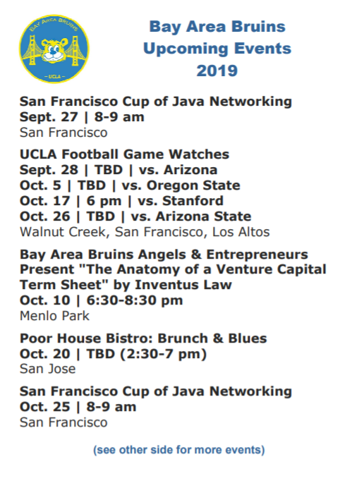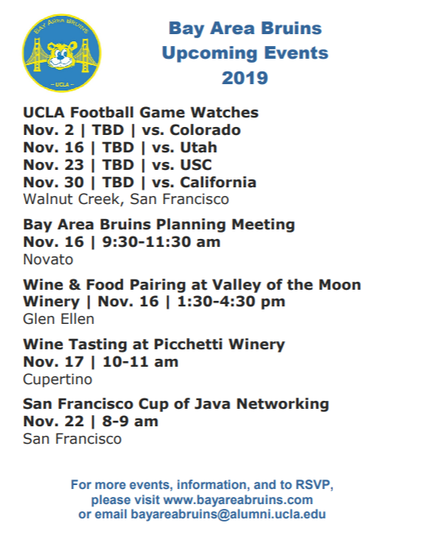

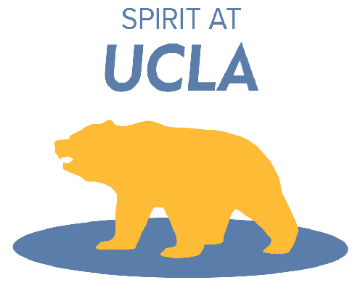[**www.bayareabruins.com**](http://www.bayareabruins.com)

